Lab 17
With the help of the Java API and using the example programs from class, create the following classes using Swing components. It should not be necessary to create separate test classes. Include the main method as a method in the class.
Exercise 1
- This frame (Width: 300 height: 300) should contain 4 components: a label with the caption “Please enter your name”, two text fields and an Enter button. Set the background colour of the frame to a colour of your choice.
- When the user enters their name in the first text field and presses the button the text from the first text field is displayed in the second text field. Use an anonymous inner class for the event handling.

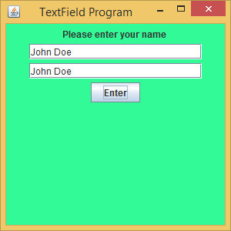
Exercise 2
This frame (W: 300, H: 250) should contain two buttons – Add and Clear, a text field with the caption “Please enter your message here”, and a text area that displays whatever is written in the text field. Again, use an anonymous class to handle the events. Again set the background colour of the frame to a colour of your choice.
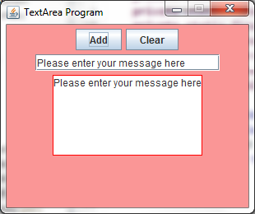

You can use the following code to create the textarea component. You should use the Java API to learn about the methods used below:

private JTextArea textArea;

textArea = new JTextArea(6,10);
textArea.setLineWrap(true);
textArea.setBorder(BorderFactory.createLineBorder(Color.red));
textArea.setEditable (false);
add(textArea);

